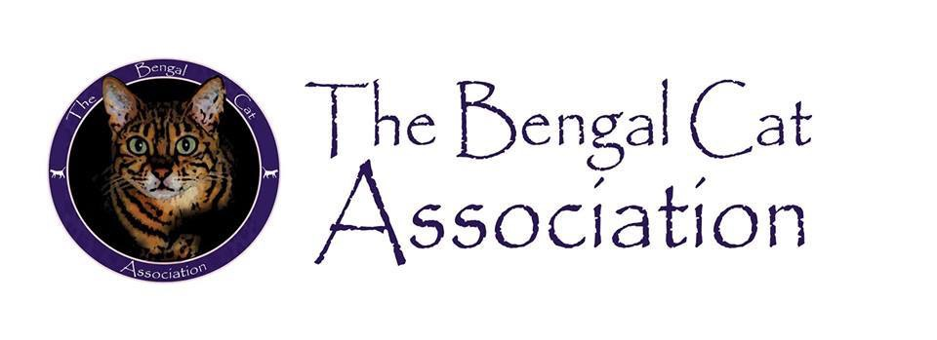
BENGAL CAT ASSOCIATION (EST. 2016)

Membership Application
Name(s)……………………………………………………………………………………………………………………………………………….
Telephone Numbers Home…………………………………………………………………………………………………..
Mobile…………………………………………………………………………………………………
Address………………………………………………………………………………………………………………………………………………………………………………………………………………………………………………………………………………………………………………………………………………………………………………………………………………………………….
Email………………………………………………………………………………………………………………………………………
Website (if applicable)…………………………………………………………………………………………………………..
Prefix (if applicable)……………………………………………………………………………………………………………….

Please select your preference for membership
- Single 1 year Adult Membership ​£5.00
- Joint 1 year Adult Membership (2 people living at the same address)​ £9.00
- Junior 1 year Membership (under 16) ​£2.00
- Single 3 year Adult Membership £10.00
- Joint 3 year Adult Membership (2 people living at the same address)​ £18.00
Please select your payment method
- Cheque - made payable to The Bengal Cat Association
- BACS – Bank transfer NatWest Sort Code:60-20-21 Acc No:37231626
- PayPal – bcatreasurer16@gmail.com

Memberships can only be accepted following committee approval.

A bit about you (Optional)
You don’t actually have to own a Bengal to belong to the Association, but it would be helpful if you could complete the section below.
The information will help us to get to know our members and discover what you would like to gain from being involved.
Do you own a Bengal(s) now?...................................................................................................
Do you plan to own one in the future?.....................................................................................
Have you owned a Bengal in the past?......................................................................................
Are you a Bengal Breeder?........................................................................................................
Do you show Bengals?...............................................................................................................

When completed, send the form, together with payment (if paying by cheque) to The Membership Secretary, Miss Debbie Rawlinson, 2 Preece Close, Newton, Hyde, Cheshire. SK14 4EE. Alternatively, if paying electronically this form can be emailed to bcatreasurer16@gmail.com .

Your personal information will be stored securely and will not be disclosed to any third party other than the GCCF if required.

Please tick below to receive news, updates and offers from The Bengal Cat Association
- I give consent for The Bengal Cat Association to communicate electronically with news, offers and services in relation to my membership.
You can opt out of receiving emails at any time. If you wish to be removed from our mailing list, please write to or email our membership secretary.

By signing this form, you are agreeing to abide by club rules and the GCCF code of ethics for Owners & Breeders

Signed 1st Applicant………………………………………… Joint Applicant…………………………………………….
Date………………………

